**Exercise 1: Setting Up JUnit**

**Scenario:**

You need to set up JUnit in your Java project to start writing unit tests.

Steps:

**1. Create a new Java project in your IDE (e.g., IntelliJ IDEA, Eclipse).**

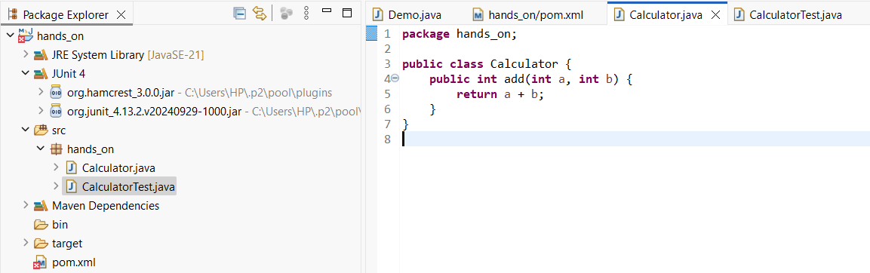

**2. Add JUnit dependency to your project. If you are using Maven, add the following to your pom.xml:**

<dependency>

<groupId>junit</groupId>

<artifactId>junit</artifactId>

<version>4.13.2</version>

<scope>test</scope>

</dependency>

**3. Create a new test class in your project.**

**Class:**

package hands_on;

public class Calculator {

public int add(int a, int b) {

return a + b;

}

}

**Test class:**

package hands_on;

import org.junit.Test;

import static org.junit.Assert.*assertEquals*;

public class CalculatorTest {

@Test

public void testAdd() {

Calculator calc = new Calculator();

int result = calc.add(2, 3);

*assertEquals*(5, result);

}

}

